[Project Number]
[Project Name]
- Introductions
  - Sign-in sheet
- EEO Construction Compliance [omit if total project <$500k]
- City of Columbus Income Tax Division [omit if total project <$500k]
- Channel of Communications:
  - Roles and Responsibilities.
  - All communications shall be through AE and OSU PM.
  - Construction hours of operation: [_________].
  - Contractor Badging Protocol.
  - Building Access.
  - Emergency Call list:
    - Form is located at http://fod.osu.edu/resources under “Construction.”
    - PM to save in e-Builder on the project Details page under the “Documents” tab.
- Safety – Accident and Security
  - In case of emergency:
    - University Police – 614-292-2121
    - Emergency Blue Light phones
    - 911 – City of Columbus Police Department
    - Emergency Call List
  - Contractor is responsible to enforce site access. No visitors are authorized on site.
  - Site Specific Safety Plan is required to be submitted to University and reviewed by University Project Manager, Office of Enterprise Risk Management (ERM) and Environmental Health & Safety (EHS).
  - Incidents/Accidents must be reported to ERM within 24 hours of occurrence and submitted via the e-B Site Safety - Incident Report (SSIR) Process.
  - A Contractor Pre Work Evaluation will be required to be completed by the Contractor during the pre-construction phase. Form available at http://fod.osu.edu/resources.
  - Additional safety guidelines, tools and forms are also available at http://fod.osu.edu/resources under “Construction Site Safety Requirements.”
- Tobacco Free Policy
  - This campus is 100% tobacco product free.
  - The university policy #7.20 is available at http://hr.osu.edu/policy/policy720.pdf.
  - The contractor shall enforce this policy for all individuals employed by the contractor, or the contractor’s subcontractors.
  - Failure to follow the policy may result in dismissal from the project.
- Sexual Harassment
  - Contractors and subcontractors are cautioned to use proper conduct while on campus. Poor reports which can be substantiated will result in the dismissal of person(s) from the project.
- Parking Permits
  - Contractor Parking Permit Request Forms are available at http://fod.osu.edu/resources under “Construction.”
  - The form must be approved by the project manager prior to submission to CampusParc.
  - Permits are required to park on campus.
  - If previously identified, onsite parking shall be reviewed with the University Project Manager.
- Paperwork Posting Requirements
  - Post necessary paperwork (EEO information, prevailing wage rates, Worker’s Compensation Certificate, Building permit, etc.) in trailer or other easily accessible location.
  - Every contractor performing work covered by the Davis-Bacon Act must post a notice (including any applicable wage determination) at the site of the work in a prominent and accessible place where it may be easily seen by employees. Link to the poster and instructions here: http://www.dol.gov/whd/regs/compliance/posters/davis.htm.
- Notice to Proceed
  - NTP information is included in the Contract Award eBuilder process (not an attachment).
  - Confirm NTP date: [______________].
  - Confirm interim milestone dates: [______________].
  - Confirm substantial completion date: [______________].
- Recommendation of Award Letters [CMR/DB only]
  - CMR/DB to initiate eBuilder process: Subcontractor and Material Supplier Declaration (SMSD).
  - CMR/DB to upload the completed Recommendation to Award Letter for university approval no later than 15 days prior to commencing the work under the subcontract.
  - Award Letters shall be written for each bid package awarded in the GMP for University approval.
- Subcontractor and Material Supplier Declaration (SMSD)
  - GC to initiate eBuilder process (SMSD) within 10 days of Notice to Proceed.
  - CMR/DB to initiate eBuilder process (SMSD) within 10 days prior to commencing work under the subcontract.
  - No payment will be made until the SMSD has been approved by the University.
  - The contractor is responsible to ensure that subcontractors (all tiers) are actively enrolled in the Ohio Drug Free Safety Program (DFSP) prior to any labor being performed on this project Include the policy number on the SMSD. Verify enrollment at the following link: https://www.bwc.ohio.gov/employer/services/StateContract/nlbwc/StateContract1.aspx.
    - For more information on the State’s DFSP policy go to https://www.bwc.ohio.gov/employer/programs/dfspinfo/dfspdescription.asp.
    - There is no exemption for out-of-state subcontractors for DFSP.
  - EDGE subcontractor and material suppliers must be identified in this eBuilder process.
- Schedule of Values (SOV)
  - GC to initiate eBuilder process Schedule of Values (SOV) within 10 days after NTP.
  - CMR/DB to initiate eBuilder process SOV within 3 business days after the Recommendation of Award is approved by the University.
  - Approved allowances are to be included on the SOV.
  - [GC] No payment will be made to the contractor until the SOV has been approved by the University.
  - [CMR/DB] No payment will be made until the SOV, RoA(s) and SMSDs have been approved by the university.
  - On the SOV, OSU requests 5-7% of the contract value to be included in the first five (5) line items listed below:
    - Bond
    - Insurance
    - General Conditions
    - Project Coordination
    - Mobilization
    - Close Out items per table below:
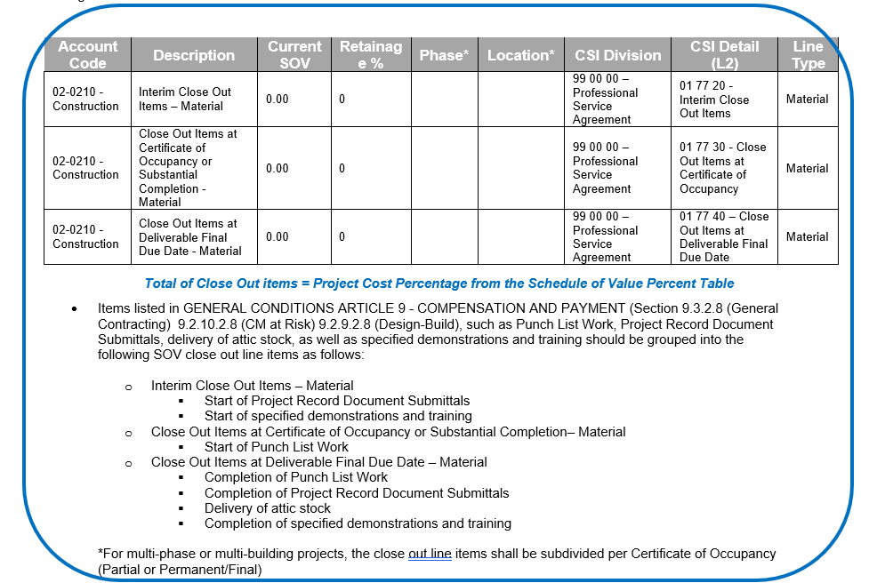
For additional information on the close out items, go to http://fod.osu.edu/resources, Post Construction/Close Out, Project Closeout Standards.
  - SOV columns in eBuilder spreadsheet:
    - CSI Divisions:
      - Level 1 and Level 2 required for University and Regional Campus projects.
      - Level 1, Level 2 and Level 4 are required for Health Systems projects.
    - Line Type:
      - Each line item must be categorized Labor or Material.
    - EDGE:
      - EDGE vendors cost must be identified as separate SOV line items.
      - Change EDGE Vendor column to YES for these separate SOV line items.
      - List EDGE vendor name in Vendor Name column.
      - Contract value on SMSD and EDGE forms must align with the amounts on the SOV.
- Request for Payment
  - Contractor to initiate eBuilder process Contractor Pay Application (CPA).
  - Prevailing Wage:
    - Contractor to contact the OSU Prevailing Wage Coordinator (prevailingwage@osu.edu) to set up eBuilder PW folders.
    - Certified payrolls to be received two weeks after initial pay period and monthly thereafter.
    - No payment will be made for subcontractors who do not have an approved SMSD in eB.
    - Payroll reports and PW documents must be provided within 2 weeks after the week the work is done.
    - Payments will be held if they do not meet PW laws as stated in the ORC, Chapter 4115.
    - Prevailing Wage information and documents are available at http://fod.osu.edu/resources.
  - [GC only] Retainage – Contractor to initiate eBuilder process Retainage Request (RETQ) after the final pay application is submitted.
  - [CMR/DB] Retainage - The contractor shall coordinate with the University Project Manager on whether retainage release will be by phase listed in SOV Phase column or at the end of the project. Release by phase will require the phase column to be completed during the SOV update process. Retainage is released by the contractor initiating the eBuilder process Retainage Request (RETQ).
- Electronic Fund Transfers
  - Contractors who wish to be set up for EFT with The Ohio State University, should visit https://busfin.osu.edu/document/vendor-maintenance-instructions or contact BF-PRSM-WEBFORM@osu.edu.
  - State Funded Contracts: Website: https://obm.ohio.gov/wps/portal/gov/obm/areas-of-interest/obm-shared-services/resources/eft-payment-authorization-agreement. (Note that contractors who are set up for EFT with the State of Ohio are not automatically set up for EFT with The Ohio State University and vice versa.)
- Materials Stored At and Off Site
  - All stored materials will be paid (with a copy of invoice(s) from the supplier attached to e-Builder Construction Pay Application (CPA) at 92% of cost). Stored Materials form and documentation is required to be attached to the e-Builder CPA process. Contractor is responsible to calculate the 92% when entering the CPA in e-Builder (no auto calculation).
- Meetings
  - Progress Meetings:
    - Recurrence (circle one): Weekly Bi-Weekly Monthly
    - Day of the week: ______________
    - Time of day: ______________
    - Meetings minutes taken by: ______________
  - Construction Site Safety Meetings:
    - To be discussed at each progress meeting.
    - Standalone safety meetings may be necessary.
    - Meeting minutes taken by: ______________
  - Additional Meetings: TBD by each project
    - Budget Review Meeting.
    - Executive Meeting.
    - Schedule Review Meeting.
    - Risk Management Meeting.
- Project Schedule
  - Expect schedule updates monthly.
  - 2 week look-ahead at each progress meeting.
  - [GC Only] If construction cost is less than $500k a bar chart schedule may be provided.
  - [GC Only] Schedule must be submitted within 30 days of contract execution and submitted monthly for review and approval prior to submitting the Construction Pay Application (CPA) process in e-Builder.
  - [CMR/DB only] Resource loaded construction progress schedule shall be submitted monthly for review and approval prior to submitting the Construction Pay Application (CPA) process in e-Builder.
  - [CMR/DB only] See section 6.5 of the General Conditions for additional schedule requirements.
- Construction Contract Modifications (Change Orders)
  - AE or OSU PM initiates the various eBuilder processes to create a construction contract modification:
    - Change Order (CO)
    - Field Work Order/Change Directive (FWO)
    - Potential Change Order (PCO)
    - Proposal Request (prpRQ)
  - The numbering of the Contract Change Modification processes noted above will be sequentially determined by eBuilder.
  - eBuilder will link processes of similar scope to each other for scope continuity.
  - Calculating CO costs:
    - Change Order costs to be summarized in the Potential Change Order (PCO) or Change Order (CO) eBuilder Process (hours, labor rates, bond costs, etc). Contractor is responsible to ensure their subcontractors have properly completed their information and attached all required back up prior to submitting for review.
    - Change Order costs must also be broken into appropriate SOV line items (labor and material) by the contractor. New SOV line items must be created to capture the scope change (refer to SOV section above for required fields).
  - [CMR/DB Only] Rates submitted on the Best Value Rating Form are to be used for all change orders.
  - Contractor to ensure their subcontractors have properly completed the subcontractor tabs and provided all required back-up before submitting for review.
  - On a <<monthly/weekly>> basis all pending RFI’s, PCO’s, FWO’s and Proposal Request are to be reviewed by the AE, Contractor and University Project Manager.
- Allowance or Contingency Authorizations
  - Contractor to initiate Contractor Allowance/Contingency Release (ACR) process in e-Builder.
    - This moves amount from contingency or allowance lines to SOV lines (see SOV section above for required fields).
    - Can bill for items once the ACR process is completed.
  - [CMR/DB Only] Contingency review/returns to be reviewed at 25% / 50% / 75% of substantial completion (per milestone dates in GMP agreement).
    - Deduct CO to be initiated by the <<AE or for DB projects the PM or Criteria AE if add’l service in contract>> for all contingency returns.
      - Contingency/Allowance Authorization (ACR) is not required.
    - See <<CMR Article 9.2.6.10 OR DB Article 9.2.5.6>> for additional information on what to include with Deduct Change Order.
- [omit for GC] CMR/DB Bid Savings
  - Can be moved to Bid Savings line via e-Builder SOV Update (SOV) process (refer to SOV section above for required fields).
  - e-Builder Contractor Allowance/Contingency Release (ACR) process to be initiated to move Bid Savings to Contingency.
  - Bid Savings return can be completed via e-Builder Change Order (CO) process from Bid Saving line or Construction line (No e-Builder ACR process required).
- Submittals/Shop Drawings
  - All submittals/shop drawings will be maintained in the eBuilder Submittal Module.
  - The AE or DB is assigned as the Submittal Coordinator.
    - Prior to starting the submittal process, the Submittal, Pre-Con & Pre-closeout (SPCP) e-Builder processes shall be initiated following OSU’s Project Closeout Standards. The SPCP process will guide the project team through the submittal log review workflow. The project team will also be able to request e-Builder training through the SPCP process.
    - The tutorial for e-Builder’s Submittal Module is available at http://fod.osu.edu/resources under “eBuilder” or at https://fod.osu.edu/sites/default/files/eb_guide_submittal.pdf.
    - It is highly encouraged for Contractors and AEs to watch the e-Builder training video on using the Submittal Module (https://www.youtube.com/watch?v=H6iEZ0VN-uA&t).
- Testing – Quality Assurance and Quality Control
  - All reports to be saved in eBuilder folder designated by OSU PM.
  - [CMR and DB Only] If testing and inspections are in the A/E scope, the <<CMR or DB>> shall incorporate tests and inspections into the schedule and coordinate the timing with the A/E and/or AOR.
- AE Field Inspection reports
  - Team to determine location and process to save AE field inspection reports to project folder.
- Photographs
  - Team to save construction progress photos in the eBuilder Progress Photos folder: Pre-Construction, Construction, Completion.
- Permits
  - Team to contact and organize necessary inspections for all project permits.
    - [add permits as needed}
    - ODIC
    - City of Columbus
    - EPA
  - Team to upload all permits into the e-Builder process Permit Info Update (PERM).
- Pre-Installation Conference & Mock-Up Reviews
  - Review mock-up requirements and mock-up approval process.
  - Submit list of mock-ups that will be completed to the A/E and University Project Manager.
- Commissioning
  - Sustainability Requirements (https://policies.osu.edu/assets/policies/sustainable-design-constrn-policy.pdf).
  - TAB Services (under A/E, CxA).
  - Contractor involvement in timing.
- Utility Markings
  - Call OUPS at 811 or 1-800-362-2764 for any public utilities that may run through campus.
  - Once an OUPS ticket is created, it is encouraged to follow up with OSU Surveying (Harry Martin at martin.117@osu.edu or 614-292-8146), ENGIE surveying (Dean Barbo at dean.barbo@engie.com or 614-306-0853) and CampusParc to confirm field activity scope.
- Utility Outage or Service Interruptions
  - Provide OSU written notice two (2) weeks in advance of any planned utilities or service interruptions. Details are available at https://fod.osu.edu/resources under “Utilities”.
- Traffic Impacts – Vehicular or Pedestrian
  - Contractor to provide two (2) weeks’ notice of any vehicular or pedestrian impacts so the OSU Project Manager can determine if it is necessary to submit a Plan Ahead request through the Department of Public Safety website (https://dps.osu.edu/planahead) for awareness and/or allocation of Traffic Control Officers.
- Equipment Training and Demonstration
  - The contractor will work with the University Project Manager to develop a suitable training schedule.
  - The contractor will maintain attendance rosters, and upload to e-Builder via submittal module for each training.
  - Contractor shall initiate the e-Builder Certificate of Equipment Demonstration (CED) for approvals.
- Attic Stock
  - At construction start the contractor will provide a list of Attic Stock material for review and submit via e-Builder Submittal Module.
  - The A/E and University Project Manager will review for accuracy.
  - The University Project Manager will identify the storage location before final delivery is made.
  - The contractor’s approved list will be used to record the location, recipient, and signer of all attic stock material.
  - The final list with signed transmittal by the University will be uploaded in e-Builder Submittal Module.
- Substantial Completion
  - Certificate of Substantial Completion (CSC) process shall be submitted by the Contractor in e-Builder.
  - Contractor to include a signed Contractor’s Punchlist with the CSC process.
  - AE to review Contractor’s Punch List and add any additional items observed or provided by the Owner.
  - Construction team to agree upon Punchlist completion dates, typically 30 days after CSC issuance.
  - Protection of the project
    - The contractor shall protect the Work from weather and maintain the Work and all materials, apparatus, and fixtures free from injury or damage until Substantial Completion of the Work.
    - After the date of Substantial Completion of the Work, the Owner is responsible for protecting and maintaining all materials, apparatus, and fixtures for the occupied portion of the Project free from injury or damage.
- Completion of Project/Closeout Documentation
  - Closeout documents shall be delivered electronically via e-Builder following OSU’s Project Closeout Standards. The Ohio State University Project Closeout Standards can be accessed via the OSU FOD vendor resource website (https://fod.osu.edu/resources) in the Post Construction/Close Out section.
  - At completion of the project, the University will require a final walk through. At this time, all instructions for equipment and maintenance manuals should have been delivered. All reports required are delivered to the A/E.
  - Before final payment can be released, the following eBuilder processes must be completed:
    - Certificate of Contract Completion (CCC).
    - Certificate of Warranty Commencement (CWC).
    - Payment Release Affidavit must be included with the final Construction Pay Application (CPA).
  - Construction As-Builts: The contractor shall keep an accurate record of all deviations from contract drawings and specifications and provide the A/E with the final and complete as-built documents upon final completion of the work.
  - AE Record Drawings: The A/E shall incorporate the as-built information into the record drawings for submission to the University at the end of the project.
- [OMIT if not a BIM Project] BIM: Model Transmission and Collaboration
  - Update BIM Execution Plan prior to the start of BIM Coordination.
  - Update monthly at a minimum
    - BIM Coordination meetings between A/E model and GC/C model are required.
    - Maintain COBie/Asset Worksheet(s) throughout the project.
    - Ensure to capture contract change modifications into the A/E models monthly.
  - Refer to the BIM Execution plan for BIM deliverable requirements.
- Site Logistics Plan
  - Noise Control.
  - Clean Project Site and Dust Control – walk off mats, HEPA filtration, construction barriers.
  - Street Cleaning.
  - Construction Fence Requirements/ Gate Access / Access from Tunnel.
  - Public Safety, Traffic Control Officers, Local Police.
  - Storage.
  - Trailer Space Availability.
  - Deliveries and Scheduling.
  - Dumpster locations.
  - Temporary Facilities.
  - Temporary Lighting.
  - Tree protection.
- Project Specific Items
  - Review Submittals/RFI’s for key stakeholders, (add/delete as needed).
    - Lock & Key, Door Hardware, Lenel Card Readers.
    - BAS: Building Automation Systems, Controls & Sequence of Operations.
    - Fire Shop – Fire Alarm Submittal.
    - DPS: Cameras, Duress Buttons, etc.
  - PM and AE are to add additional items.

